Wintershall The Nativity
Following the success of our trip to 'The Life of Christ' at Wintershall in the summer, we are planning to return in December to see their re-enactment of The Nativity - 'A refreshing antidote to the rampant glitz' . We have planned to go on Saturday 15th December 5pm, this date is a popular date so please let Carol Stacy or Rev Trish know asap, if you are interested in joining us. If you can’t make this date and time it runs from 12th-16th December at various times during the day so that you can pick a time to suit you. There is a flyer in Linch Church and more details can be obtained from www.wintershall-estate.com OR 01793 418299

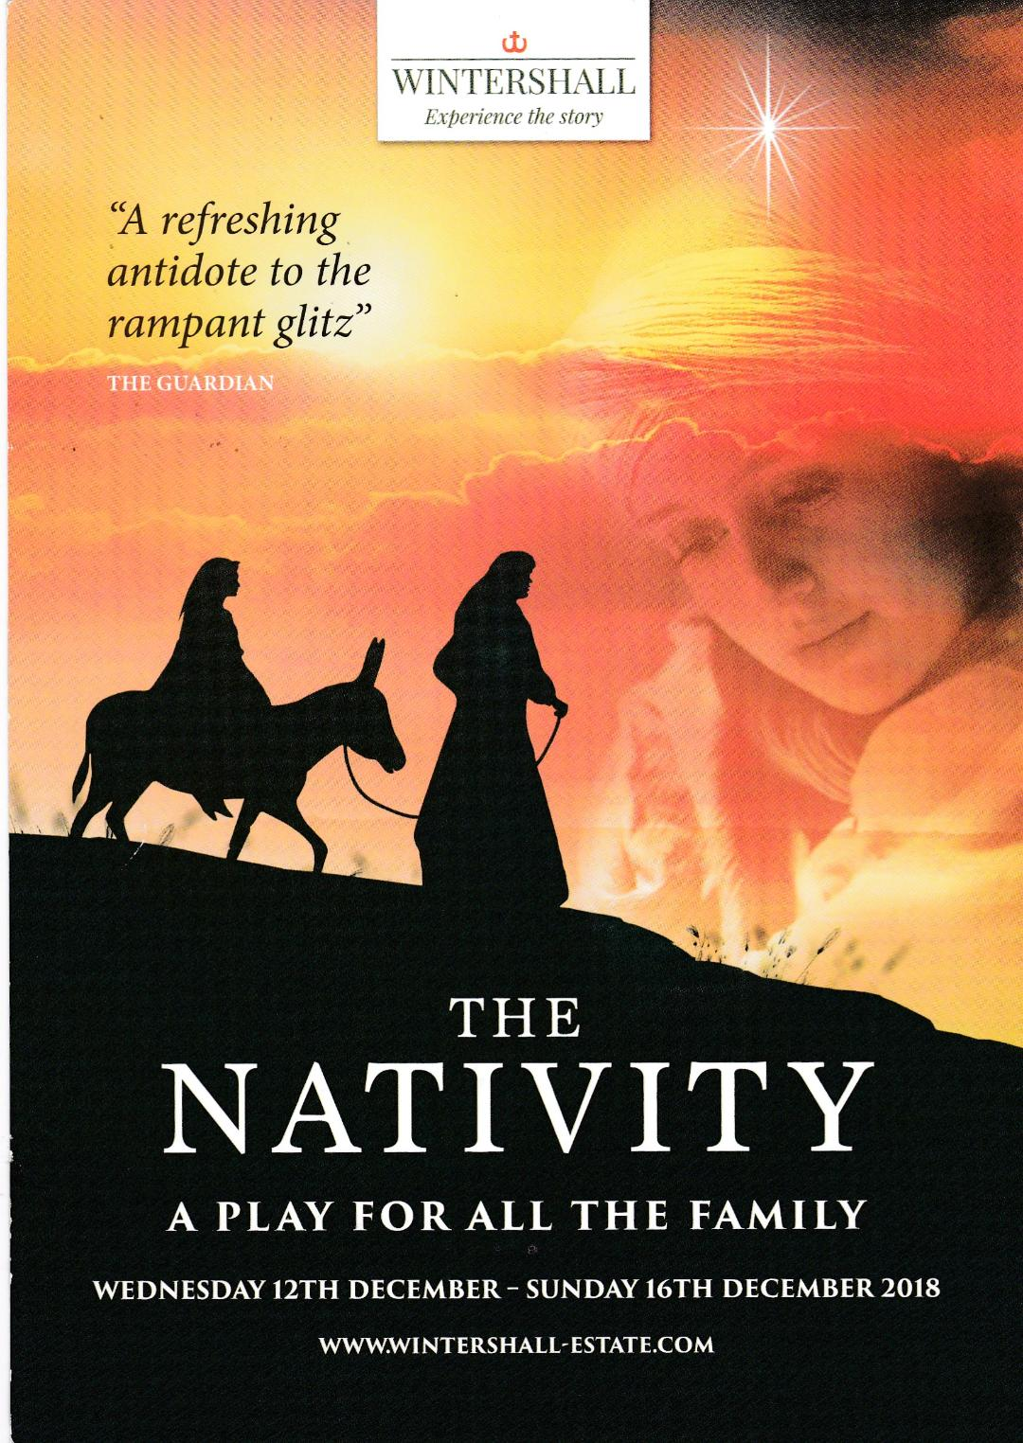

REMEMBRANCE 2018

TO MARK THE CENTENARY OF THE ARMISTICE 1918
“TO END ALL WARS”
AN EVENING OF SONG,
POETRY & PROSE, HUMOUR & PATHOS
IN AID OF
THE ROYAL BRITISH LEGION
SATURDAY 3rd NOVEMBER AT 7.30PM
RAKE VILLAGE HALL
(GU33 7JA - BEHIND THE FLYING BULL)
TICKETS £15.00 (£5.00 under 16) from
MILLAND & ROGATE VILLAGE STORES, THE RISING SUN
Or email: mvmh.enquiries@gmail.com

Remembrance Services Sunday November 11

Linch 10.50am Rembrance Day Service followed by a short service at Iping Marsh

Milland 10.50am Rembrance Day Service followed by a short service at Rake War Memorial

Stedham 10.50am Rembrance Day Service Service followed by a short service at Iping

